Overview & Navigation
The Approve Payable Time page displays reported time entries needing manager approval. The report is broken down by entry filtered to the user’s search preferences such as Time Reporting Groups, Business Unit, Supervisor IDs, and date ranges. It is imperative that at least one selection criteria value be entered.
Click the “NavBar” icon  Then click the “Navigator” icon 
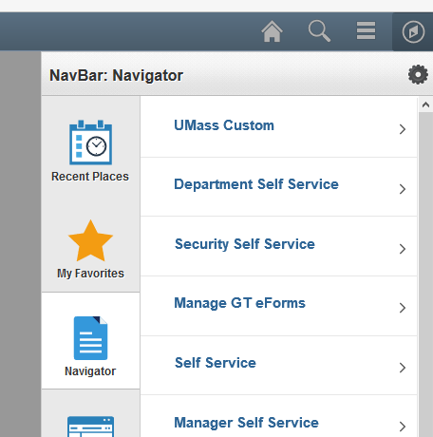

- Click the Manager Self Service link

- Click the Time Management link

- Click the Approve Time and Exceptions link

- Click the Payable Time link

Employee Selection
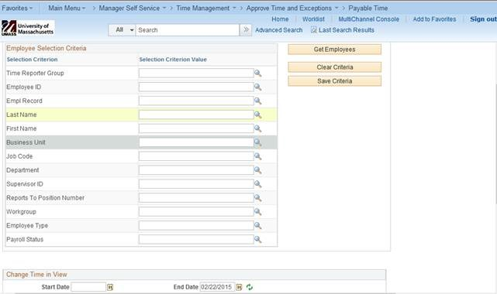

Use the Employee Selection Criteria section to select a group of employees, individual employee, and a date range as applicable to view time entries needing manager approval. It is imperative that at least one selection criteria value be entered.
For example, you could enter a Time Reporter Group or a Business Unit or your Supervisor ID AND always enter a start date.

- Time Reporter Group: Enter the Group ID of the team needing time approval in the text field or look up the Group ID using the icon.  - Business Unit: Enter your Business Unit in the text field or look up the Business Unit using the using the icon.  - Supervisor ID: Enter your Supervisor ID in the text field | - Start/End Date: The Start Date field defaults to blank and the End Date field defaults to the Sunday of the following week. Enter the range of dates for the time needing approval by entering dates in the text field or by using the icon. Once entered click the icon to reload the page.  Get Employees: Click to return search results and refresh the page.
Employee Search Results
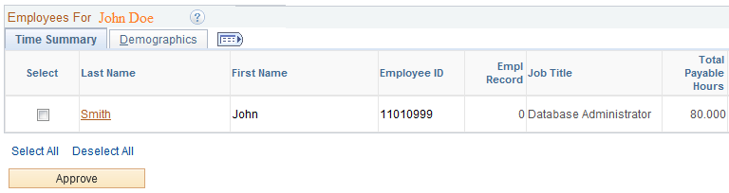
The results of the search are viewable at the bottom of the page under the Employees For Your Name section, and display totals for Total Payable Hours, Base Hours, Time Off, Additional Reported Time, Shift and Differentials, and Paid as Units.
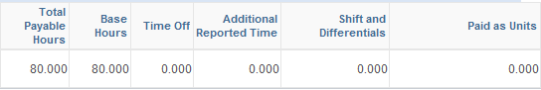
To review and approve an employee’s detailed hours by day, click the hyperlinked Last Name of the results to view the time entry.

Approve Payable Time
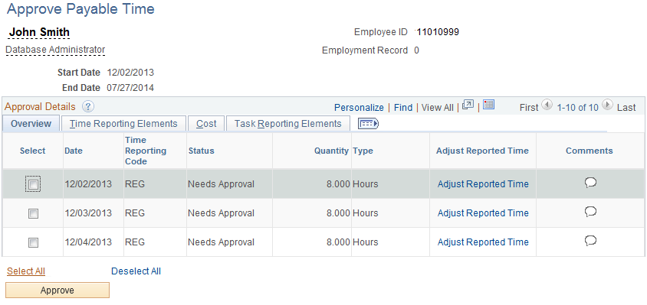
To approve summarized payable time, select the checkboxes correlating to times that are to be approved. Use Select All at the bottom of the page to select all times on the screen. Click to submit your approval. Once submitted, a confirmation page will appear stating your time has been successfully submitted.

